**World Quant University**

**Professor: Steven Stelk**

**Risk Management**

Nikolas Lippmann Pareschi - [nikolaslippmann@gmail.com](mailto:nikolaslippmann@gmail.com)

##### ***Dynamic Hedging & Risk Mitigation***

I. Download data for last 5 years Dow Jones Industrial Average futures contract – consider the nearest month expiry always.

II. Also download/access relevant Options data for DJIA – consider the earliest expiry Put Option contract that is just at-the-money

III. Consider any particular trading month during the past 2 years (choose a month with not too many holidays).We would start trading with on the first day of the trading month.

IV. Consider that the trader has an initial position of SHORT Position of 100 at-the-money Put Options of DJIA at the end-of-trading on the last trading session (mostly a Friday, WorldQuant University, 2014 Page 2 unless Friday was a holiday) before the beginning of the Monday on which we start trading.

V. If the earliest expiry Options/Futures contract expire midway into the month, roll your positions over to the next contract

Steps 1 to 5 were done here with the help of the code provided in the piazza forum:

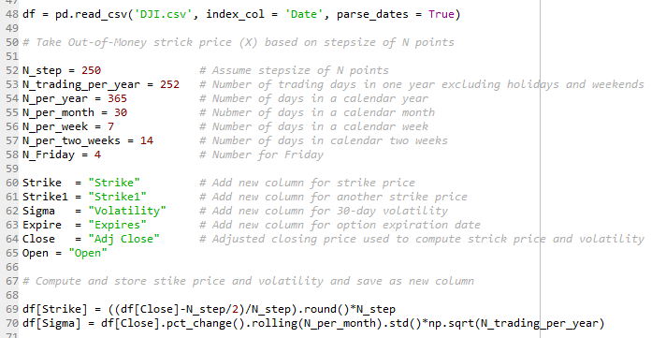

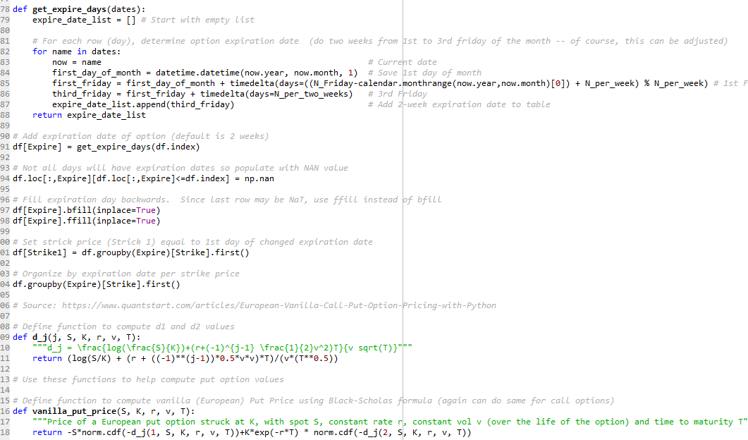

We made some adaptations to the provided code so for example we could compute the price of options considering the opening of prices:

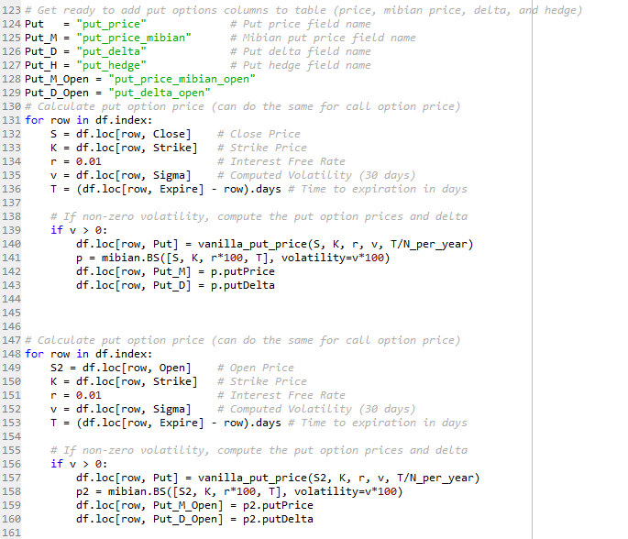

VI. Given the spot price of DJIA at close on the last day of trading before the current Monday, calculate the initial Delta of the SHORT Option Position. This initial delta would provide an estimate of the overall Risk exposure of the SHORT Option Position.

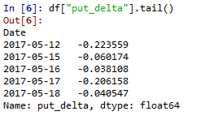

Which is computed here:

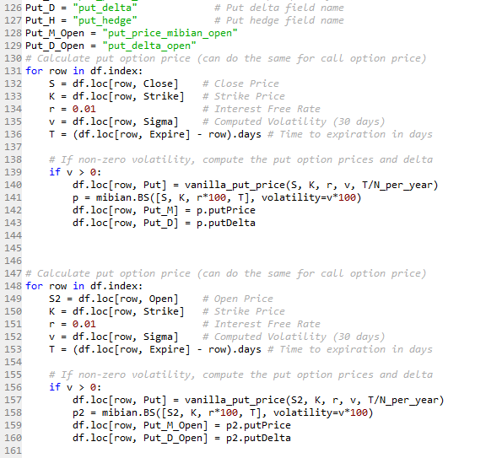

VII. To delta hedge the short put, calculate the number of DJIA Futures contract (earliest expiry) the trader needs to buy/sell at the beginning of Trading on Monday. The idea is that the deltas of the short option and the short stock would cancel, yielding an overall delta of zero.

Normally an ATM option has a delta of 0.5, which means that one needs half a contract of the spot future to hedge. If it is a short call one needs to be long the underlying. The formula is simple, one just need to multiply the delta by the unit of the contract. This under the premise that one could buy/sell a fractionary lot of a contract. If we do not have this premise we can use the minimum multiple of the option and the future contract (under the premise the one will have the money for that).



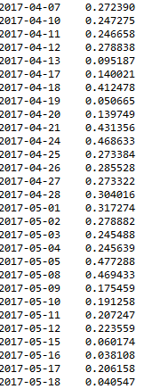

Code:

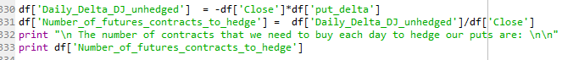

VIII. Then on, track the underlying spot price twice every day – just after market open and just before market close to adjust your delta hedge positions by buying or selling the required number of futures contracts

IX. Continue the dynamic hedging process till the last trading day of the month

As one will buy the amount of DJs to hedge the delta in the options, in the open one will have zero delta. In a perfect world with constant delta hedging the delta will be zero.

As we are doing only 2 times we will have the delta that will be the difference betweeen the end of the day. We calculate the number of contracts necessary to hedge twice a day considering this:

Code:

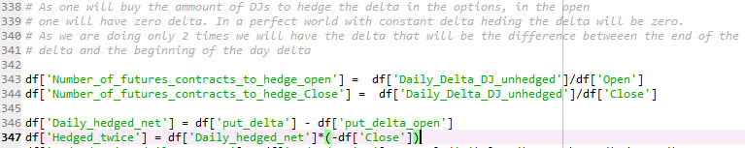

Results:

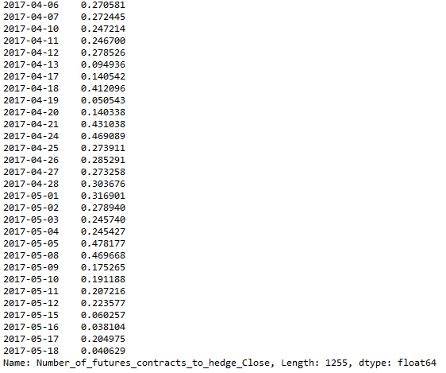

X. Graphically represent the following –

Code for next graphs:

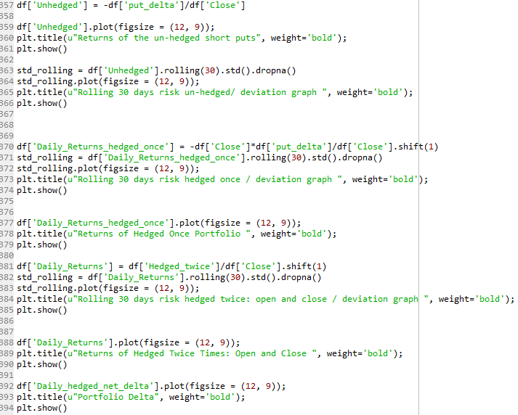

* the risk and return profile of the un-hedged Options SHORT positions

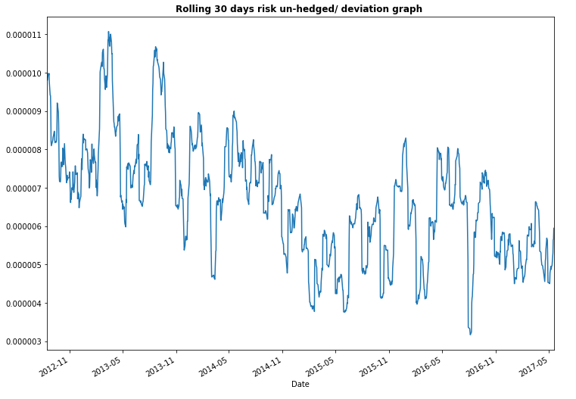

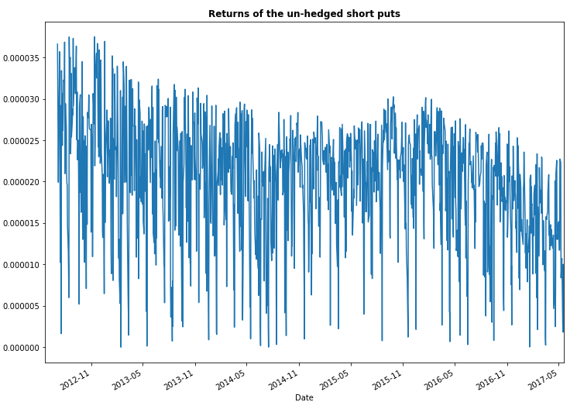

* the risk and return profile of the dynamically hedged portfolio

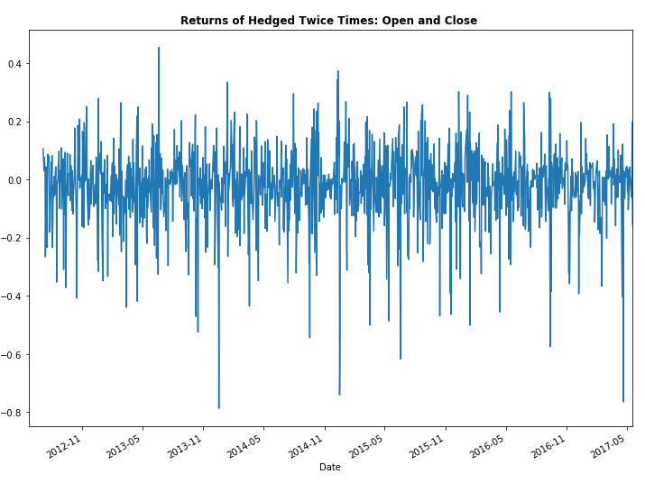

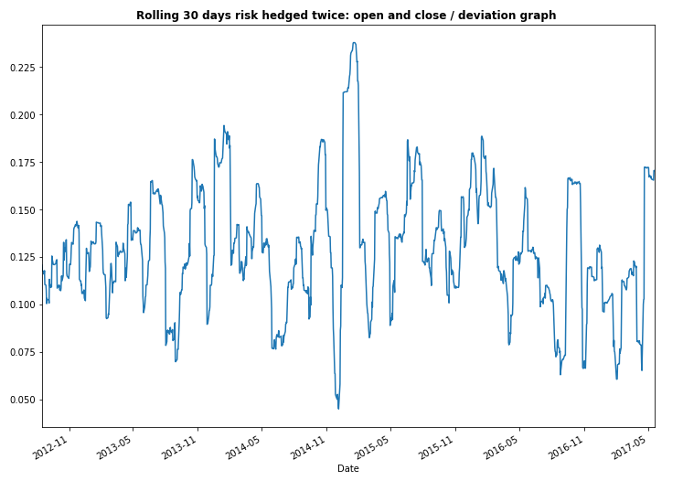

* The delta of the portfolio

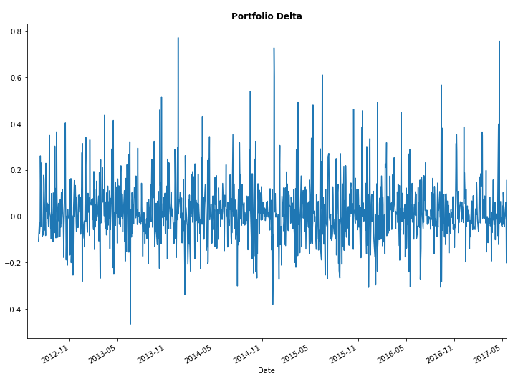

* the cumulative quantity of futures contracts that were required to dynamically hedge the portfolio

Code:



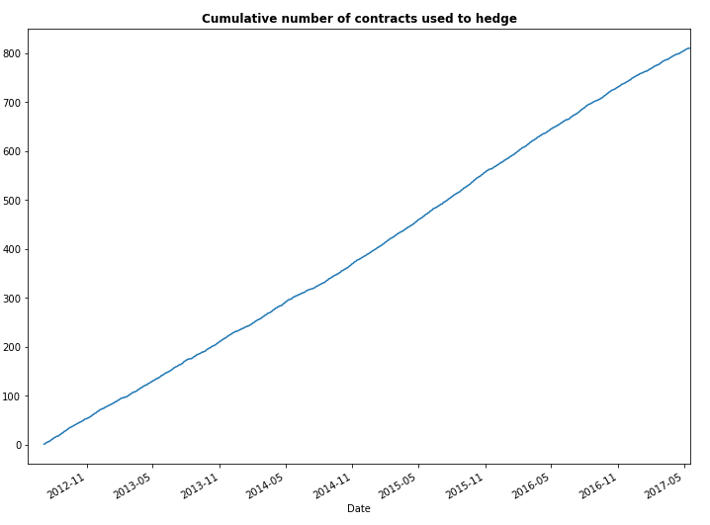

Note: Risk-return profile calculations should include calculations for the following KPIs –

i. Average Daily Return,

ii. Percentage of Positive Days,

iii. Average Weekly Return,

iv. Max Daily Drawdown,

v. Max Drawdown,

vi. Lake Ratio &

vii. Gain to Pain Ratio (modified to smaller time frame)

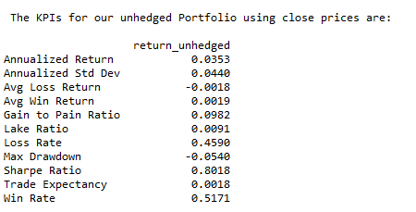

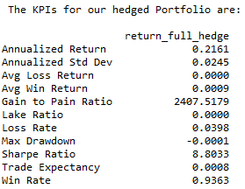

**Analysis**:

* In this example we adjusted our Hedge twice a day. Is this frequency too less/too much? Analyze and explain.

I believe this frequency is too less. As the returns showed, there is a high variance even hedging in the open and in the close. To really hedge and have a delta near to zero we would need to do it more often. As DJ is a very liquid instrument it would be possible to do even in lower timeframes.

* Analyze and report the Risk & Return characteristics of the two portfolios – the unhedged one and the one with Dynamic Hedging. Do they lose money overall? Which one is the riskier to trade?

They both make money. This happen probably because we have time decay in our favor. When we sell puts we have time decay in our favor and also we are delta positive. So overall the markets went up (which benefits the unhedged position) and we had the time decay in our favor.

* In case the dynamically-hedged portfolios is losing money, is a negative Gamma responsible for the same? If so, how did the negative Gamma materialize in the portfolio. Can Dynamic Delta Hedging ever offset the effects of a negative gamma in the portfolio?

Negative Gamma is not responsible for that because it acts sometimes in a way that benefits us and other times not. This is not deterministic. We could do some gamma hedging but that would affect the delta hedging which is usually more important. The exception would be very out of the money options.

* Does the Dynamic Hedging strategy overall auger a favorable risk-return profile? How would the strategy stand up against sudden unfavorable price shocks in the spot price?

Overall Dynamic Hedging is a great strategy with favorable risk-returns profile. It is some kind of arbitrage in which the trader captures the theta in its favor, as he is not affected in thesis by market movements. But the hedging need to be made in higher frequencies, to avoid for example intraday price shocks in the spot price.

* Would Dynamic Hedging of a positive Gamma position make money overall? Why? What effect will it have on the risk of the portfolio?

This is dependent on the way that the spot price will move. It will usually benefit from strong moves. It will lose money in a environment of lower volatility.

* What effect would increasing/decreasing volatility in prices of the underlying have on the frequency of Dynamic hedging and the risk of the overall portfolio?

A higher volatility environment would require a higher frequency of dynamic heding. It would increase the risk of the overall portfolio and it would also increase the costs of trading (broker commissions).